Memory Echoes
Flag: PacketCapture{3ch0_1n_7h3_r36157ry}
Category: Digital Forensics
Tools used: Python, strings
Steps:
1. Start point: MFT.dd (9 KB).
- What I found: the file begins with "FILE" signatures, so it is a raw dump of NTFS Master File Table records. It holds 9 records: services.exe, notepad.exe, rundll32.exe, taskhostw.exe, winlogon.exe, cmd.exe, update_agent.dll, explorer.exe and svchost.exe.
- Thinking: every record's $DATA is the same filler text ("System file content holder."), so the real content had to be in whichever record didn't match the rest.
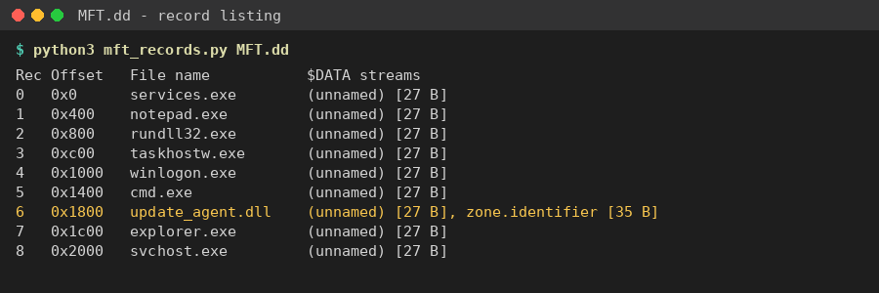
MFT records: only update_agent.dll has a second, named $DATA stream
2. Pivot: the odd record, update_agent.dll.
- What I found: this is the only record with a second, named $DATA attribute. That is an Alternate Data Stream called "zone.identifier".
- Thinking: ADS are a classic hiding spot because Explorer and `dir` don't show them. The real Windows stream is "Zone.Identifier" and holds plain text like "[ZoneTransfer] ZoneId=3". This one held 35 bytes of unreadable data, so it was disguised as something harmless.
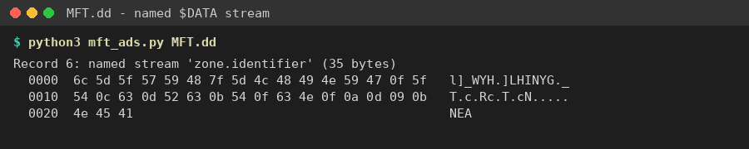
The 35-byte "zone.identifier" stream
3. Pivot: the hidden stream's bytes.
- What I did: pulled the 35 bytes out with Python: 6c 5d 5f 57 59 48 7f 5d 4c 48 49 4e 59 47 0f 5f 54 0c 63 0d 52 63 0b 54 0f 63 4e 0f 0a 0d 09 0b 4e 45 41
- Thinking: no zlib, base64 or other file signature, but the values are clustered like text. That points to a single-byte XOR.
4. Decoding.
- What I did: tried all 256 single-byte XOR keys and kept only the outputs that were fully printable.
- Result: key 0x3C gives PacketCapture{3ch0_1n_7h3_r36157ry}. Every other printable output was gibberish.
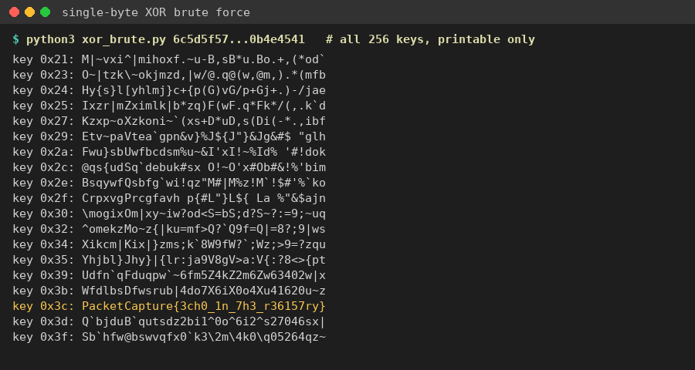
Single-byte XOR brute force: key 0x3C gives the flag
Key insight: in a set of identical-looking records, look for the structural outlier, here the one file with an extra named data stream. Short opaque blobs are often single-byte XOR, so brute-forcing all 256 keys is quick to try. The flag text ("echo in the registry") matches the challenge story.

